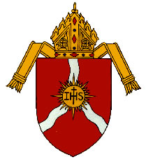Diocese of Shreveport
Catholic Schools’ Office
3500 Fairfield Ave
Shreveport, LA 71104
318-868-5057 (fax)

Enrollment Form
2023-2024 School Year

School: (circle one) JGS LCP OLF SFHS SJB SJS

Date: (circle one) August 18 August 25 September 1

Grade | Number of Students
PK-2
PK-3
PK-4
K
1st grade
2nd grade
3rd grade
4th grade
5th grade
6th grade
7th grade
8th grade
9th grade
10th grade
11th grade
12th grade
TOTAL:

Email: cshively@dioshpt.org (preferred)
Fax: 318-868-5057; Attn: Sr. Carol Shively, OSU
(318-868-4605 backup fax as last resort!)

revised 7.2023

